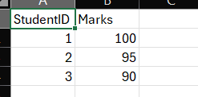
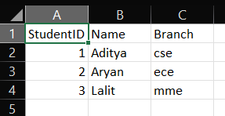
Task 1 : Create Student Info.csv Task 2 : Create Student Marks.csv

Task 5: Use VLOOKUP to merge
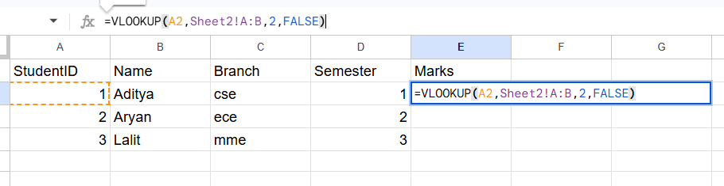
Task 6: Use IF ERROR to handle missing values
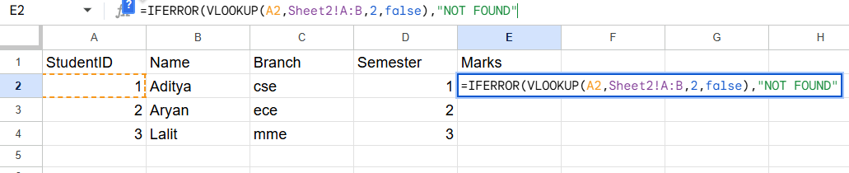
Task 7: Final Merged Table
